**-: Recommendation System :-**

Recommender systems are designed to recommend things to the user/customer based on various factors. Based on user choice, these systems predict the most likely product that the users are most likely to purchase and are of interest to. Nowadays big companies like Netflix, Amazon, etc. use recommender systems to help their users to identify the correct product or movies for them.

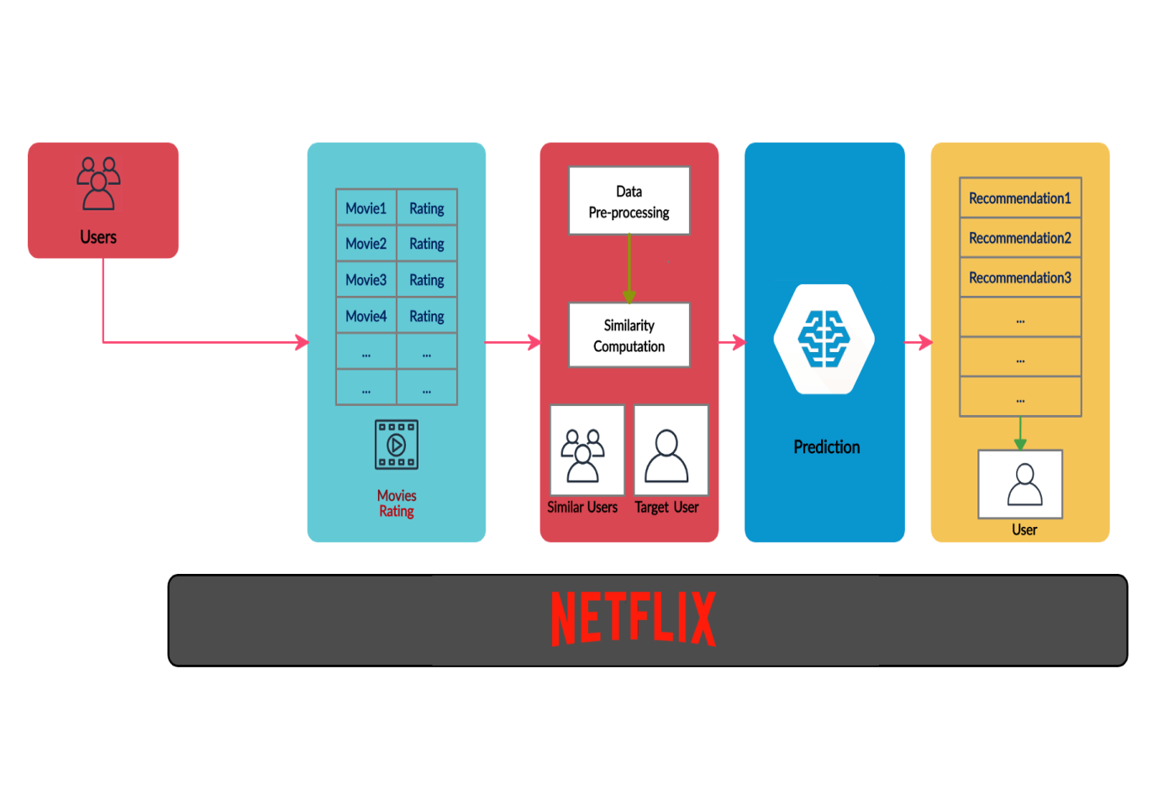

The recommended system deals with a large volume of data present by filtering the essential data based on the data provided by a user and other factors that take care of the user’s preference and interest. It finds out the match between user and item and imputes the similarities between users and items for recommendation.

Both the users and the services provided have benefited from these kinds of systems. The quality and decision-making process has also improved through these kinds of systems.

**Recommendation Engine Benefits:-**

1. Drive Traffic - A recommendation engine can bring in traffic to your site. It achieves this with customized e-mail messages.
2. Deliver Relevant Content - By analyzing the customer’s present site use and previous browsing history, a recommendation engine can deliver relevant product suggestions as he stores.
3. Engage Shoppers - Consumers dive even more deeply into the product line without needing to search for a search.
4. Increase Average Order Value - Average order values generally go up when a recommendation engine is used to show tailored alternatives.
5. Increase Number of Items per Order - When the customer is revealed options that fulfil his interest, he is most likely to add choices to his purchase.
6. Reduce Workload and Overhead - Utilizing an engine automates this process, reducing the workload of your IT staff and your spending plan.



## ****Types of Recommendation System:-****

### ****1) Popularity-Based Recommendation System:****

This type of recommendation system operates on the principle of popularity or anything trending. These systems check about the products which are in trend or are most popular among the users and directly recommend those.

Example:- If a product is purchased most frequently by new customers, the system will get to know that that product is most popular among new customers. Then the system will recommend that product to new customers, and chances become high that the new user will also purchase that.

#### ****Merits of popularity based recommendation system:****

1. It does not suffer from cold start problems which mean on day 1 of the business also it can recommend products on various filters.
2. There is no need for the user’s historical data.

#### ****Demerits of popularity based recommendation system:****

1. Not personalized.
2. The system would recommend the same sort of products/movies which are solely based upon popularity to every other user.

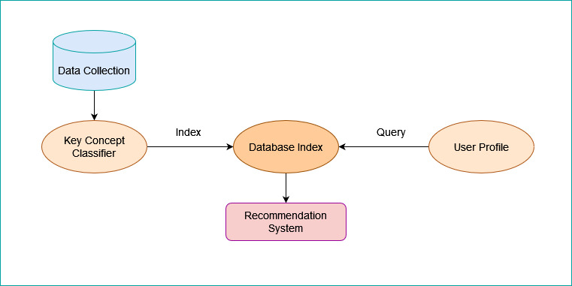

### ****2. Classification Model:****

#### A classification model tries to draw some conclusions from the input values given for training. It will predict the class labels/categories for the new data. Feature: A feature is an individual measurable property of a phenomenon being observed.

#### ****Limitations of Classification Model****

i. It is a rigorous task to collect a high volume of information about different users and also products.

ii. Also, if the collection is done then also it can be difficult to classify.

iii. Flexibility issue.

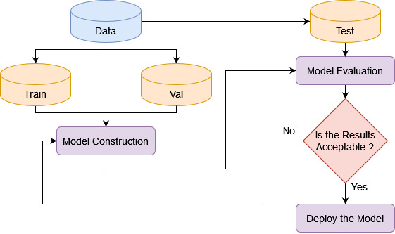

### ****3. Content-Based Recommendation System:****

This type of recommendation system works on the principle of similar content. Here you create tags to every item and on the basis of similarity of tags you recommend something. There are various fundamentals attributes that are used to compute the similarity while checking about similar content. Let us see an example to understand it better.

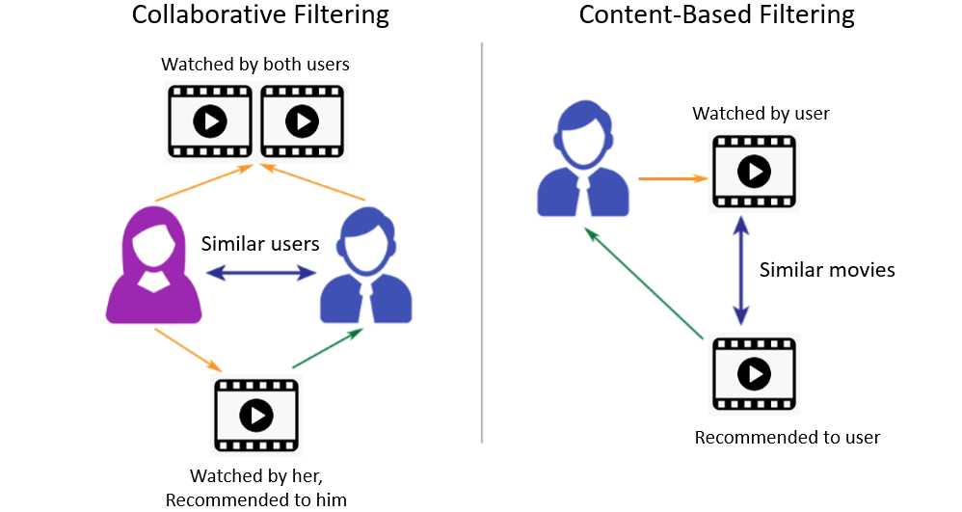

**Example** – Let us assign a user U1 and he likes to watch movies. Here the item/product is movies. The characteristics of movies like adventure, action, comedy are called genre. Now he watches a movie M1 whose genre is adventure and gave a rating of 5 stars to it. He watches another movie M2 and gave a rating of 4 stars. Now you see that both the movies are of adventure genre. When we apply content based similarity to these data the algorithm will focus on item similarity. Now if a new movie releases M3 is adventure genre and have same actors, same type of plot; M3 will be recommended to user U1.

#### ****Merits****

1. There is no requirement for much of the user’s data.
2. We just need item data that enable us to start giving recommendations to users.
3. A content-based recommender engine does not depend on the user’s data, so even if a new user comes in, we can recommend the user as long as we have the user data to build his profile.
4. It does not suffer from a cold start.

#### ****Demerits****

1. Items data should be in good volume.
2. Features should be available to compute the similarity.

### ****4. Collaborative Filtering****

  It is considered to be one of the very smart recommender systems that work on the similarity between different users and also items that are widely used as an e-commerce website and also online movie websites. It checks about the taste of similar users and does recommendations.

**Example** – Here you collect and analyse data for multiple users. For simplicity let’s take two users U1 and U2. Suppose user U1 sees a movie M1 and gives a rating of 5 star and co-incidentally user U2 sees the same movie M1 and gives a rating of 5 stars. Again user U1 sees a movie M2 and gives a rating of 5 star and user U2 also sees the same movie M2 and gives a rating of 4 stars. From here you can notice that both the users have same taste of genre and give or like to watch top-rated movies.

Now when user U1 will watch movie M3 and give a high rating. Movie M3 has a high possibility that user U2 will also like it and give a high rating or nearly to it.



#### ****Limitations****

1. Enough users required to find a match. To overcome such cold start problems, often hybrid approaches are made use of between CF and Content-based matching.
2. Even if there are many users and many items that are to be recommended often, problems can arise of user and rating matrix to be sparse and will become challenging to find out about the users who have rated the same item.

**Note:-** For content based algorithm works on the basis of content/item similarity and for collaborative filtering algorithm works on the basis of user characteristic/similarity

**References:-**

[1] Resnick, P., & Varian, H. R. (1997). Recommender systems. *Communications of the ACM*, *40*(3), 56-58.

[2] <https://tryolabs.com/blog/introduction-to-recommender-systems>

[3] <https://www.analyticsvidhya.com/blog/2018/06/comprehensive-guide-recommendation-engine-python/>